How to generate entities from the database in IntelliJ IDEA

1. Got to File => Project Structure, open Modules, click “+” and add JPA module.
2. Go to View => Tool Windows => Persistence
3. Right click on the project in Persistence => Generate Persistence Mapping => By Database Schema  
   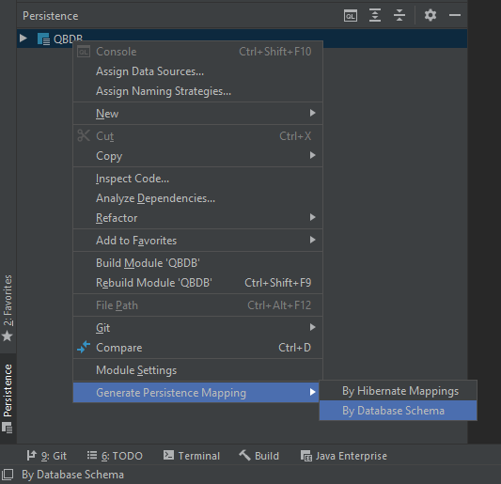
4. Click on the three dots near the Choose Data Source  
   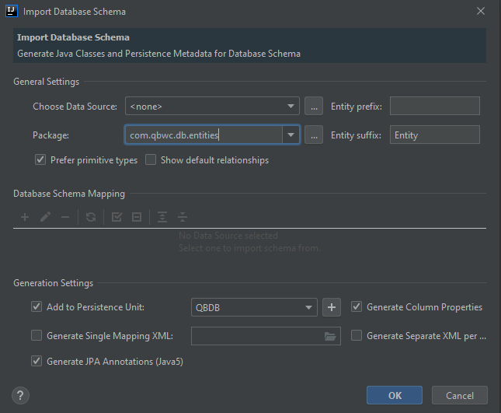
5. Click “+” and add MySQL  
   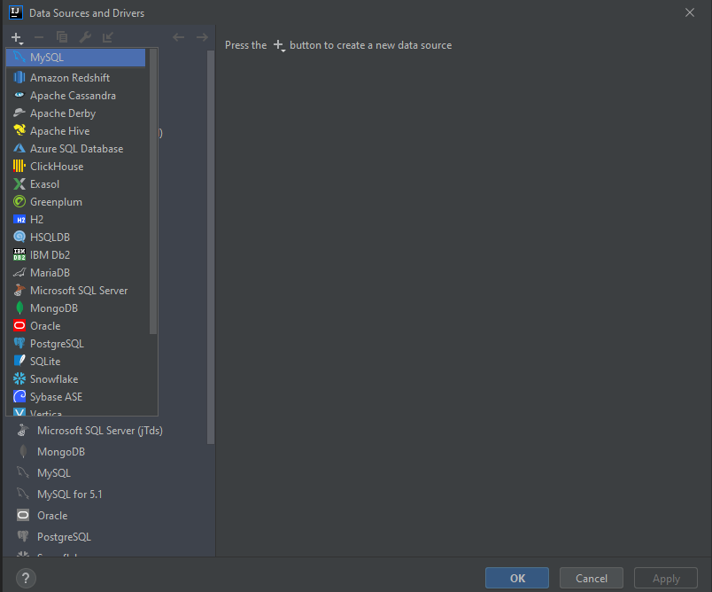
6. Fill in the settings for connection and test it  
   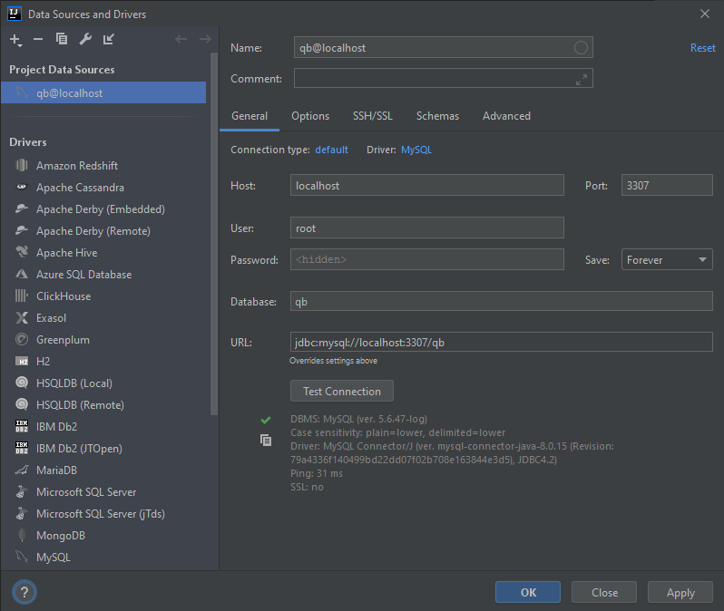
7. Choose the database, check all tables except for schema_version and make sure that all columns are checked.  
   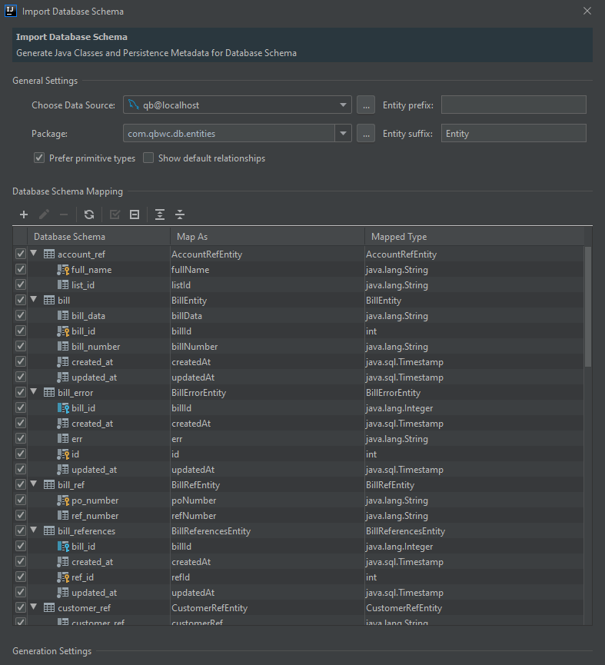
8. Click Ok and generate the classes
9. Find created_at and updated_at columns and change their annotations as shown below.

@CreationTimestamp  
@Basic  
@Column(name = "created_at", nullable = true, updatable=false)  
  
@UpdateTimestamp  
@Basic  
@Column(name = "updated_at", nullable = true)

*Command line for Maven configuration is “flyway:migrate clean install”